INSTRUCTIONS FOR BUYER
REGISTER TO PARTICIPATE
Sourcing Fair of Supporting Industry 2023

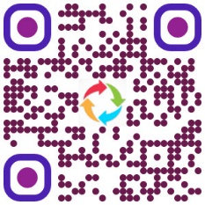
STEP 1: From May 1, 2023 to July 31, 2023.
- Buyers register to participate and provide the Organizing Committee with a detailed list of components to look for suppliers at: https://rtlink.me/sfs23-buyer or scan the QR code next to).
STEP 2: From August 1, 2023 to August 10, 2023.
- The Organizing Committee provides a list and profile of supporting industry enterprises with appropriate capacity for Buyers.
Buyers choose the right list of supporting industry businesses to connect B2B.
STEP 3: From August 10, 2023 to August 15, 2023, the Organizing Committee arranges a direct connection schedule and sends it to the Buyer.
STEP 4: On August 25, 2023, the Buyer meets directly with the supplier at the event "The conference to find support industry suppliers in 2023".
For more information, please contact:
Ho Chi Minh City Support Industry Development Center:
Address: 163 Hai Ba Trung, Vo Thi Sau Ward, District 3, Ho Chi Minh City.
- Mr. Le Ngoc Thanh: 0966 381818 - Email: lnthanh.sct@tphcm.gov.vn
- Mr. Vu Kien Nam : 0349 662994 - Email: namvkin123@gmail.com
We look forward to receiving your interest and registration.

